Professor Kalpdrum Passi

Virtual Reality

Spencer Pylatuk, Clement Mindjimba

**Introduction**

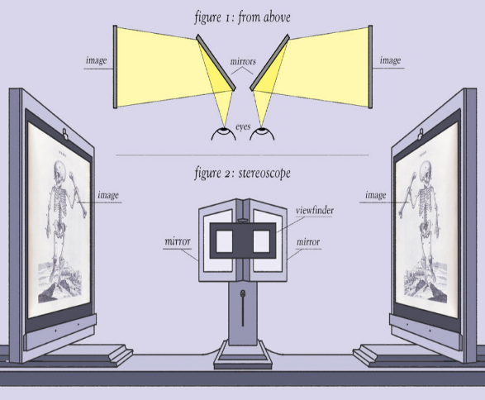Virtual Reality has been around for 169 years. It is Charles Wheatsone who first described the perception of 3D images by binocular vision in 1838. He invented a stereoscopic viewing device that was used to view prepared images in 3D, that later became the famous toy the Viewmaster (Cummings)­ The concept of virtual reality is creating a simulation of a three-dimensional world, using computer technology, that the user can explore and feel as if they were in that world (intro2). However, there are different kind of virtual environment that make the user feel more or less in a virtual world. In general a virtual reality experience includes three-dimensional images that appear to be real and the ability to track the user’s motions and, as the user moves, there is a change in perspective (still with the goal of making the experience feel real.

*Timeline ("Timeline of Virtual Reality History & Important VR Chronological Events" 2015)*

1909:Mechanical Simulators.

1929: Concept for electronic simulators.

1945: Point light source projection (simulating runaway lights).

1956:“Sensorama”, the first VR machine, was invented by Morton Heilig.

1961:“Headsight”, the first VR helmet, was created by Corme and Byen.

1965:“Ultimate Display”, a VR helmet with two CRT screens, was created by Ivan Sutherland. 1966:Thomas A. Furness III creates the first flight simulator for the Air Force.

1968:Ivan Sutherland creates the first virtual reality and augmented reality HMD which he named “The Sword of Damocles”.

1979:McDonnell-Douglas Corporation incorporates virtual reality into its HMD.

1987:Dimension International company developes a software with the capability to 3D worlds in a personal computer.

1989:ATARI launches the first video game machine with 3D technology to the mass market.

1991:Antonio Medina creates a virtual reality system to drive the Mars robot rovers from Earth. This system also known as “Computer Simulated Teleoperation”.

Virtuality launches its new level of immersiveness. It is also the first mass-produced VR entertainment system that can support multi-player and networked. This machine was a big achievement in virtual reality history.

1994:SEGA releases SEGA VR-1.

2010:Google introduced a stereoscopic 3D mode version of Street View.

2014:Facebook acquires Oculus VR, a virtual reality headset company, for $2 billion.

**Immersive Vs Non-Immersive**

*Immersive*

Immersive virtual reality is surrounding the user of the VR system in images, sound or other stimuli that provide an engrossing total environment. The sense of immersion perceived by the user depends on a few parameters: the field of view of resolution, the update rate, contrast and illumination of the display. There are different ways and different technologies to achieve this goal: CAVE virtual reality systems, flight simulator… (Types of VR System)

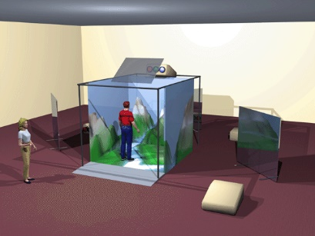 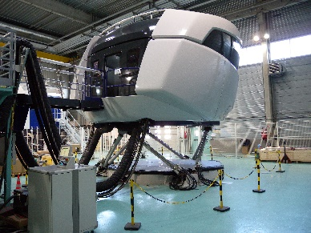 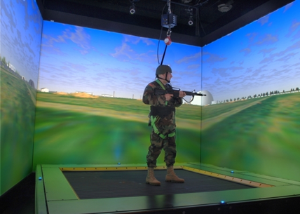

*Non-Immersive*

|  |  |  |
| --- | --- | --- |
| **Main Features** | **Non- Immersive VR** | **Immersive VR** |
| Resolution | High | Low - Medium |
| Scale (perception) | Low | High |
| Sense of situational awareness | Low | High |
| Field of regard | Low | High |
| Lag | Low | Medium - High |
| Sense of immersion | None - low | Medium - High |

Non-immersive is the least immersive implementation of Virtual Reality, for example, a desktop system where the virtual environment is viewed from a screen. Mostly, the interaction with the virtual environment (the screen) is possible with the use of a keyboard or a mice. (Types of VR System)

**Technologies**

*Early Technologies*

We have mostly heard about virtual reality in the past few years with the rise of virtual glasses and headsets accessible to everyone (anyone can get a pair of glasses for $50). Indeed virtual reality is taking over the video game industry, and the fact that big companies like Facebook who bought Oculus VR for $2.3 billion is a proof that virtual reality is not going to fade anytime soon.

However, virtual reality has been around for about four decades. Douglas Engelbart laid the groundwork for the creation of computers that were based on transistors and would be more user-friendly. Following Engelbart’s vision, the military started designing radar systems that would be able to process information and instantly display it to a screen. Moreover, aircraft designers and computer experts started to restructure computers so they would graphically display and computer data. By 1962, Ivan Sutherland developed what is called “Sketchpad” which was the first computer-aided design program (Virtual Reality: History). The idea was to use a pen that would allow the user to draw images on a computer. By the end of the 1960s, these innovations opened a whole new world to different industries. This is when Engelbart created the first mouse. In fact, industries specialized in architecture, engineering, automobiles could all use these innovations to be more productive and create more complex and better work.

We cannot talk about virtual reality without talking about flight simulator. Indeed, the military spent millions of dollars in which was one of the most influential antecedents of virtual reality following World War II. It is Luther G Simjian who invented the first flight simulator, the Optical Range Estimation Trainer (“Luther G Simjian”, 2016), which taught pilots how to determine the range of an airplane in flight.

*Modern Technologies*

When comparing modern virtual reality technology to early predecessors, there are easy to spot differences that make sense when looking at a history of the technology, however to summarize, it can be generally said that virtual reality technologies like HMDs (Head Mounted Displays) have become more affordable, smaller and less bulky, and more powerful in terms of what they can render. For example, let’s compare the Sword of Damocles (Developed by Ivan Sutherland and Bob Sproull) and the newer Oculus Rift. Developed in 1968, the Sword of Damocles was capable only of displaying wireframe rooms – Not to mention it was such a heavy display that it was, out of necessity, mounted to the ceiling. (Kostov, 2015) When compared to the Oculus Rift, which is simply worn over one’s head and is capable of rendering scenes in extreme levels of detail, the progress made within the field is staggering. For example, this capture from the game *Elite: Dangerous* serves to demonstrate the massive strides made in the graphics capability of virtual reality headsets like the Rift or the Vive.

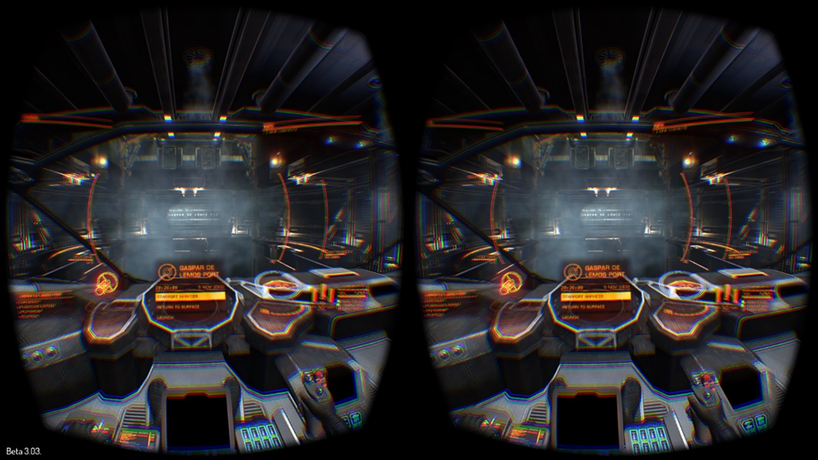

In addition, Oculus’ Rift weighs a mere 470g, barely more than a pound – When compared to the Sword of Damocles that needed to be mounted to a ceiling, the Rift serves to demonstrate how much the technology has been miniaturized and improved upon.

**Military and Virtual Reality**

When Virtual Reality as an attainable goal became mainstream and popular among gaming communities around the time Oculus announced their development kit, one application that was overlooked by most was the use of Virtual and Augmented Reality technology in the military field. It’s important to note that while militaries around the world have embraced virtual reality as a safer, more cost effective form of training, it’s clear that it’s not a suitable replacement, but rather it can serve as an effective complement to real, in the field training. There are however, uses in the military beyond training. The use of software like Dragon (A 3 Dimensional Battlefield viewer displayed below) in conjuction with a VR headset like Oculus’ Rift or something similar allows military personnel and high ranking officers an easier way to view the battlefield so that they can quickly and efficiently plan for any situation (With more ease and accuracy than traditional 2D maps on a table or computer screen). Another potential application of VR technology in the military is the preparation of crews to deal with emergency situations not directly related to combat – For example, the United States military is considering virtual scenarios aimed at education and preparation of sailors to fight fires onboard combat ships. (Strickland, 2007) Another extremely exciting prospect for military training is the advances made to flight simulation technology. Huge strides have been made since Microsoft Flight Simulator X, and technology has now advanced to the point where it’s possible to step into a cockpit built to scale, featuring full controls and even dynamic rotation, banking, and turbulence systems.

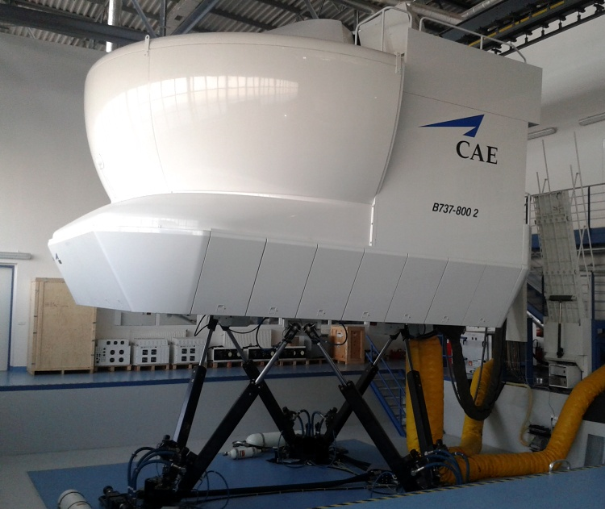 Flight training systems like the one developed by CAE - pictured here - are quite common among airlines looking to train pilots fully before they’re placed into a scenario they may be uncomfortable with in the air. Applied to the military sector, this allows pilots to train in state of the art simulators like this one and be fully prepared once they step into the real thing. As both a means to save on operation costs and reduce the risk of accidents, this technology has a lot to offer. It also serves to demonstrate the difference between immersive and non-immersive virtual reality technology – While immersive experiences often involve a headset and some form of hand controls for interaction, semi immersive technologies like this full room flight simulator bridge the gap between simulation and reality by placing pilots in a full scale, factory accurate recreation of the cockpit of a helicopter, commercial plane, or military jet, bringing them that much closer to real life during training. Through the use of haptic and force feedback, the pilot can feel, learn, and understand how the plane will respond in different situations so that it can be handled properly when they operate the real thing. (“Types of Virtual Reality”)

Moving from combat and flight training into a post-deployment application, using virtual reality to treat PTSD in soldiers returning from combat is quickly being recognized as much more effective than traditional means. In a paper from the Journal of Traumatic Stress, it’s noted that statistically significant results can be seen when treating veteran soldiers with VR technology over traditional methods, including soldiers diagnosed with Post Traumatic Stress Disorder caused by everything from IED (Improvised Explosive Device) detonations to triage medical treatment in the field and everything in between, as well as general (Not otherwise specified) anxiety disorders. At a rate of 62% improvement, the results are nothing to turn your nose up at. (Reger, Greg M., et al. "Effectiveness of virtual reality exposure therapy for active duty soldiers in a military mental health clinic." Journal of traumatic stress 24.1 (2011): 93-96.) This particular application opens many potential doorways into the realm of treating other mental disorders using VR – By effective use of VR by the military to treat PTSD, there’s no reason to think it couldn’t be used to treat things like depression or anxiety – An exciting prospect, especially when you consider most developers and innovators originally intended to use virtual reality for games and recreation. In terms of combat training, a suite of software from a South Korean developer allows soldiers to train in everything from Sniper/Spotter situations to parachuting into combat zones, all from the safety of a secure environment with a VR Headset (In this case, an Oculus Rift). Another benefit is that computer simulations can more accurately track statistics, for example, the article mentions that Call of Duty tracks each bullet fired in competitive matches, and this formula could easily be ported into military training software to more accurately refine a soldier’s skillset with regards to firearms. (Parkin, 2015)

**Medicine and Virtual Reality**

*Types of Virtual Reality In Medicine*

Window on the World is a computer-like system, the user look at the information through a display screen. It is useful for different types of medical visualisation (e.g. Virtual colonoscopy). It can also be used for simulating certain medical procedures. However, there is one problem with creating windows on the world for surgery purposes and it is designing realistic haptic devices. Indeed, they are very expensive and are only application speciﬁc.

Hand on Virtual Worlds is a stereo display that allows the user to actually put his hands into the virtual world, which makes interaction with the image possible through a “general purpose haptic device” (Gillies). Devices like that have been applied to simulating laparoscopic procedures.

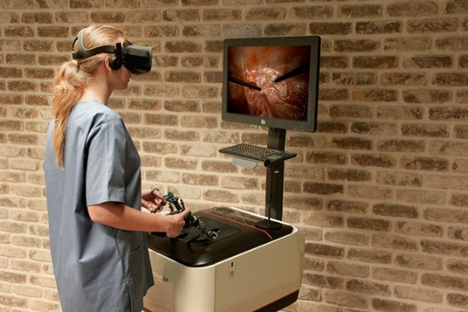

Immersive systems (head mounted displays) are used as an alternative to head tracking systems. The whole idea behind this technology is to block out the real world to provide an immersive experience. However, because of many drawbacks they have never been used for medical purposes (restricted ﬁeld of view with no peripheral vision, unnaturally close image, isolation and fear of real world events, uncomfortable to wear). There is also CAVE systems that could be used for medical applications (simulating operating theatre dynamics). There could be many benefits from this technology: high resolution and large field of view, real and virtual objects can be mixed, many people have access to the same experience at the same time. However, it is very unlikely that they will be used for medical purposes because of some major drawbacks: the system is expensive, require large physical space, projector calibration must be maintained at all time, physical objects cannot be easily incorporated (Gillies).

Telepresence is the control of sensors and manipulators by a human operator. There are many applications that uses telepresence, including military vehicles driven by an operator from distance. It is also used in medicine for endoscopic or robotic surgery (Gillies)

*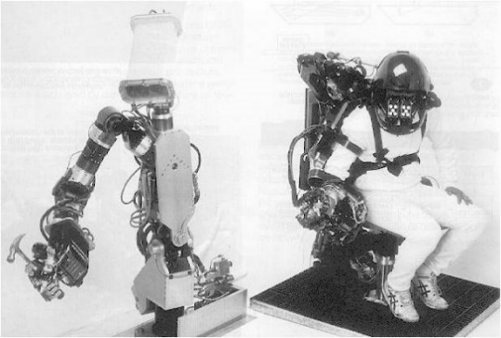Applications of Virtual Reality in Medicine and Surgery*

“The healthcare sector is one of the biggest adopters of virtual reality” (Virtual Reality In Surgery, 2017). In medicine, virtual reality is used for training, assessment and certification, and telepresence.

It has shown benefits in surgery as it plays an important role in training surgeons. Virtual reality allows surgeons to train and gain experience in a safe environment, they cannot harm the patient and receive feedback as they train. For example, University of Montreal has developed virtual reality simulator, called SIM-K, which teaches doctors how to perform knee replacements (Gardner, 2016). It has also shown benefits with new technologies: robotic surgery which is a robotic arm controlled by a surgeon, allowing the surgeon to have more precise movements. “The robotic device is accurate, meaning smaller incisions, reduced blood loss and faster recovery” (Virtual Reality in Surgery, 2017). Another use of this technology is remote telesurgery, the surgeon operates on a patient who is in a different location. On the same idea than telesurgery, virtual reality is also used for telementoring. Indeed, sometimes surgeons perform complex procedures that require all of their skills and experience. They can be compared to athletes, no matter how good they are they all have and need a coach. Telementoring provides this opportunity: ” Now, using augmented reality technology developed at the University of Alabama at Birmingham, surgeons can have their mentor virtually join the operation while it’s underway” (Gardner, 2016).

*Architecture of a medical VR system:*

COMPUTER INTERFACE HUMAN

Graphical Display

(easy)

Rendering Engine

(easy)

Computer Models

Geometric (easy)

Physical (easy)

Tactical Feedback

(very difficult)

Mechanical Interface

(moderately easy)

Audio Interfaces

**Perception**

As with any new and evolving technology, there will always be those resistant to change, determined to stay in the past. Though there are many who quickly and accurately point out flaws and criticize where necessary, (Bletter, 38-44), it’s very easy to see with the staggering number of uses in a wide variety of fields, from flight and combat simulators to treatment of PTSD for soldiers past and present, to applications in medicine and recreation, that the public - both private citizens and larger companies and organizations – are all more than willing to adapt and learn to use these technologies. From the military claiming that VR training is both better in quality and efficiency (Stone) to more accessible, more affordable forms of virtual reality entertainment in the form of games and other media, you’re not likely to find many people opposed to VR. While there are certain uses of VR that one could easily criticize as a means of wasting more time than humans do already (Via virtual reality games or other media), it’s clear that the technology itself is receiving nothing but praise as a means to do everything from treating PTSD to engineering new buildings or infrastructure. In any case, most of the concerns are unsubstantiated, arguments merely along the lines of “We’re not sure if it has health risks, so that means Virtual Reality is bad.” (Matthews, 2016) Most other complaints are less to do with hardware, and more to do with the financial aspect of the technology – It’s expensive, it’s not as accessible as it should be, it’s not providing returns to investors, it’s not appealing to casual users as much as it is to hardcore gamers and enthusiasts.

**The Future of Virtual Reality**

As Virtual Reality technology advances and becomes more mainstream, we see two main side effects become more frequent and more impactful. Not only has it become more affordable and easier to access in recent years, but also, and perhaps more important when related to course content, headsets and other virtual reality hardware are now able to support and render graphics with amounts of detail several orders of magnitude greater than what was once possible, as well as offer increased levels of control and interaction with software like games or flight simulators. Increases in desktop processing power and mainstream hardware developers like nVIDIA and AMD including drivers and support for headsets like Oculus’ Rift or HTC’s Vive means that as it becomes more affordable and easier to access for the majority of the population, developers working at companies like Google and Facebook can pioneer new innovations and uses for virtual reality. As it stands, many of these companies already employ developers whose responsibility is strictly related to the development and integration of virtual reality technology and software into everyday experiences. Facebook, for example, invested $250 Million dollars in further development of software with the ultimate goal of “connecting people all over the world through virtual experiences.” (Fermoso, 2016)

As companies expand and grow, and new companies enter the battle to lead the market, and in any industry or market, new companies means competition, and competition means rapid advancement in what’s possible as companies compete to become the king of VR. In terms of future technology, an article on the future of virtual reality applications in the military offers insight into potential haptic and other sensory feedback including the smell of gas leaks, the heat of a burning pipe, etc. (“Virtual and Augmented Reality: What's Next for Military Training Technology?”, 2017) With regards to training in military and humanitarian situations, as well as situations, for example, in which someone is being trained to treat a patient or a person with PTSD, or assess risks based on emotion and body language, it’s noted that we’ll likely see improvements in facial animation and interaction within virtual reality programs. Though not directly related to the hardware, these features are more important when you put them into a virtual environment where the user is focused on small details as well as the bigger picture. In general, however, the future of VR will likely lead to technology that leaves less of a physical footprint (Smaller, lighter, less invasive), is more immersive (In terms of image and sound quality, performance, etc.), and is more affordable. All of these factors seem to suggest that VR will only become more widespread in everything from recreation in the form of games and other media, to training in situations from military to medical and everything in between. As displayed in the chart below, sales of Virtual Reality 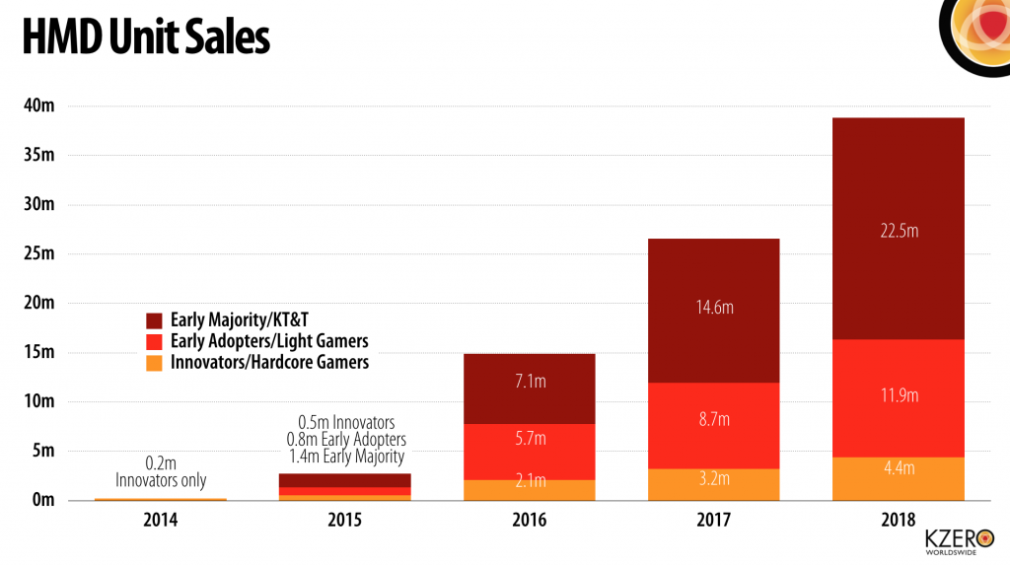HMDs (Head Mounted Displays) are growing steadily, with no sign of slowdown in the near future. (Chart courtesy of KZero.co.uk) (End of future)

In terms of practical hardware, developers like Microsoft are in the early stages of allowing users to interact with software using only hand gestures, eliminating the need for controllers and bringing the user one step closer to full immersion. (Parkin, 2015)

To summarize, Virtual Reality is a technology that has been present in our world for over a hundred years, depending on what you consider to be virtual reality. From beginnings in mechanical simulators and wireframe rooms to small, head mounted displays capable of rendering in complete detail any world imaginable. Of course, there are limitless possibilities that this technology can be used for and applied to – We’ve barely scratched the surface. From the military and medicine to mining, engineering, and space training, virtual reality has the potential to change for the better the way that we train, treat, and support people working in dangerous fields. Of course, there are also recreational uses, and from social networking to video games and interactive media, developers across disciplines are now eager to make the next leap into the future of virtual reality, bringing us closer and closer to being able to step into other worlds, and believe that it’s real, or communicate face to face with someone across the world, or see places we could never travel to normally. Virtual reality is an exciting technology in every field of technology from public to private, and promising developments and booming sales can only mean great things for its future.

Bibliography

Cummings, Curtis. “Virtual Realty Technology: Its Early History.” Co-Create Digital Innovation, Revelry.com, 6 Sept. 2017, revelry.co/virtual-reality-technology/.

Fermoso, Jose. “Facebook invests $250m more in VR as Zuckerberg shows off wireless Oculus.” The Guardian, Guardian News and Media, 7 Oct. 2016, www.theguardian.com/technology/2016/oct/06/zuckerberg-facebook-virtual-reality-wireless-oculus-connect-3.

Gardner, James A. “Augmented and Virtual Reality in Medicine: 6 Applications We're Keeping Our Eye On.” MedTech Boston, MedTech Boston, 23 May 2016, medtechboston.medstro.com/blog/2016/05/24/16045/.

Gillies, Duncan. “Virtual Reality in Medicine and Surgery.” Imperial College of London Department of Computing, Imperial College of London, www.doc.ic.ac.uk/~dfg/OtherLectures/VirtualRealityInMedicine.pdf.

Kostov, Georgi. “Fostering Player Collaboration Within a Multimodal Co-Located Game.” ResearchGate.net, ResearchGate.net, Sept. 2015, www.researchgate.net/figure/291516650_fig2_Figure-22-The-Sword-of-Damocles-by-Ivan-Sutherland.

“Luther G. Simjian.” Luther G. Simjian - Engineering and Technology History Wiki, Ethw.org, 3 Feb. 2016, ethw.org/Luther_G._Simjian.

Matthews, Kayla. “Virtual Reality Still Has 5 Big Problems to Overcome.” MakeUseOf, MakeUseOf, 8 June 2016, www.makeuseof.com/tag/virtual-reality-still-5-big-problems-overcome/.

Parkin, Simon. “​How VR is training the perfect soldier.” Wareable, 31 Dec. 2015, www.wareable.com/vr/how-vr-is-training-the-perfect-soldier-1757.

Strickland, Jonathan. “How Virtual Reality Works.” HowStuffWorks, HowStuffWorks, 29 June 2007, electronics.howstuffworks.com/gadgets/other-gadgets/virtual-reality.htm.

Strickland, Jonathan. “How Virtual Reality Military Applications Work.” HowStuffWorks Science, HowStuffWorks, 27 Aug. 2007, science.howstuffworks.com/virtual-military4.htm.

“Timeline of Virtual Reality History & Important VR Chronological Events.” All Virtual Reality, AllVirtualReality.com, 17 Feb. 2015, allvirtualreality.com/tutorials/timeline-virtual-reality-history-important-vr-chronological-events.html.

“Types of VR System.” Types of VR system, www.agocg.ac.uk/reports/virtual/37/chapter2.htm.

“Virtual and Augmented Reality: What's Next for Military Training Technology?” Cubic Corporation, Cubic Corporation, 2 Mar. 2017, www.cubic.com/News/Blog/Articles/ID/1809/Virtual-and-Augmented-Reality-Whats-Next-for-Military-Training-Technology.

“Virtual reality in surgery.” Virtual Reality Society, Virtual Reality Society, 28 June 2017, www.vrs.org.uk/virtual-reality-healthcare/surgery.html.

“Virtual Reality: History.” VIRTUAL REALITY - History, University of Illinois, archive.ncsa.illinois.edu/Cyberia/VETopLevels/VR.History.html.

Picture References

https://revelry.co/virtual-reality-technology/

http://www.iucr.org/__data/assets/image/0019/6490/Image15.jpg

https://farm6.staticflickr.com/5012/5573996984_d9b21880f0_o.jpg

https://www.extremetech.com/wp-content/uploads/2013/04/ARL_ODT.jpg

https://cdn.arstechnica.net/wp-content/uploads/2014/11/ed-Rift-Screenshot_0004.jpg

http://www.catc.cz/photo-pg-20---.jpg

http://4.bp.blogspot.com/-sFiUgwLXnYY/T0DkrOkQnXI/AAAAAAAAAR8/Zdx-wvyJzOQ/s1600/Picture1.jpg

http://www.kzero.co.uk/wp-content/uploads/2014/07/vr-hmd-unit-sales-1024x573.png